DATES AND REMINDERS FOR VOTER REGISTRATION VOLUNTEERS

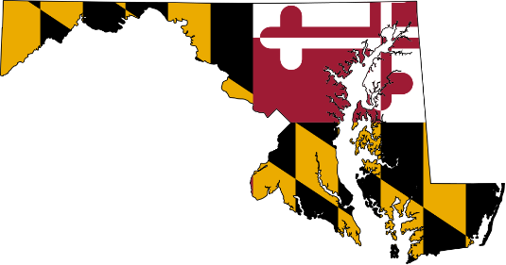

2020 Presidential General Tuesday, November 3, 2020 7:00AM – 8:00PM

Early Voting: Monday, October 26, 2020 – Monday, November 2, 2020 7:00AM – 8:00PM

Close of Registration Tuesday, October 13, 2020 05:00PM Office 11:59PM On-Line
- Close of registration date is the latest you can turn in your paperwork.

- During Early Voting and Election Day, we will have ‘Same Day Registration”, a person will be allowed to change their address or register to vote with a valid driver’s license or a Maryland State ID card. This is the ONLY way they will be allowed to register or make any address changes.

- Effective, March 10, 2016, if you have been convicted of a felony and have completed serving a court-ordered sentence of imprisonment, you are eligible to register to vote.

You do not qualify to register to vote if you have been convicted of buying or selling votes.

- A 17 year old may vote in the Primary Election if they will be 18 years old by the General Election Day. As an example, for the Presidential General Election in 2020; the Date of the General Election is Tuesday, November 3, 2020. If a person is 18 by that date they may vote in the Primary Election which is Tuesday, April 28, 2020.
Baltimore County Board of Elections
11112 Gilroy Rd. Ste. #104
Hunt Valley, Md. 21031
410-887-5700

Contact Information: Mary-Frances Alcoser 410-887-0979 direct
mvavraalcoser@baltimorecountymd.gov

