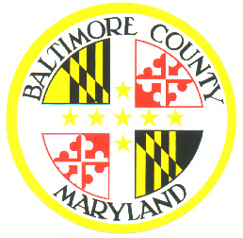
Baltimore County Board of Elections
11112 Gilroy Road, Suite 104
Hunt Valley, MD 21031
410-887-5700

Recognized Political Parties in the State of Maryland

- Bread and Roses
Website: info@breadandroses.us

- Democratic Party
Baltimore County Democratic Party
301 Allegheny Ave.
Towson, MD 21204
Baltimore County Democratic Party
PO Box 19092
Baltimore, MD 21286
Website: www.mddems.org
Email: info@baltimorecountydems.com
443-407-6022

- Green Party https://www.gp.org/

- Libertarian Party https://lpmaryland.org/

- Republican Party
Mailing Address:
Republican Party of Maryland
PO Box 631
Annapolis, MD 21404
Website: www.mdgop.org
Email: info@mdgop.org
443-906-3534

- Working Class Party
Email: www.workingclasspartymd@gmail.com

